Data/Specyfication | Visualization
Coordinate system  range: [-6,6] x [-6,6] | 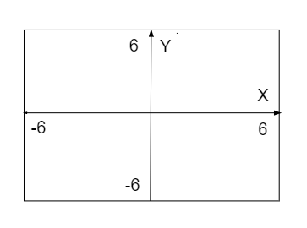
Line L1 (red):  2x+3y=9  A1=(-9/2,6) B1=(6,-1) | 